**COOKBOOK**

**TEAM DETAILS**

* Team leader: B.Bharath kumar - [smartbharath046@gmail.com](mailto:smartbharath046@gmail.com)
* Team member: A.Vignesh – [vickyanandan9710@gmail.com](mailto:vickyanandan9710@gmail.com)
* Team member: P.Guruprasath – [Gprasath771@gmail.com](mailto:Gprasath771@gmail.com)
* Team member: A.Joseph Antony – [josephicsanthony@gmail.com](mailto:josephicsanthony@gmail.com)
* TEAM ID : SWTID1741326638146407

**INTRODUCTION**

**CookBook** is an advanced React.js application designed to revolutionize the way culinary enthusiasts and professional chefs discover, organize, and create recipes. Catering to both novice cooks and seasoned professionals, CookBook offers a user-friendly platform to explore culinary delights, learn cooking techniques, and foster a vibrant community united by a shared passion for the art of cooking. Featuring a clean interface with the iconic React logo as a favicon and a warm, earthy "Village Cooking Theme," the dashboard provides a suite of tools: recipe browsing with lazy loading, category navigation, search functionality, detailed recipe views with YouTube videos, trending dishes, and a responsive layout.

Powered by React.js, react-router-dom for navigation, axios for API integration, and APIs from <https://recipe-backend-tgsm.onrender.com/recipes>, Recipe dataset and YouTube, CookBook empowers users to embark on a gastronomic journey where innovation seamlessly intertwines with tradition. With features like dynamic search, visual recipe browsing, and comprehensive recipe management, CookBook transcends the boundaries of culinary experiences, sparking inspiration and fostering collaboration within the culinary community. Elevate your culinary endeavors with CookBook, where every recipe becomes an adventure waiting to be discovered and savored.

**DESCRIPTION**

Welcome to the forefront of culinary exploration with CookBook! This cutting-edge web application is meticulously crafted to provide an unparalleled culinary adventure for passionate cooking enthusiasts and seasoned professional chefs. Designed with a commitment to user-friendly aesthetics and robust features, CookBook reshapes how users interact with recipes, offering a platform that not only sparks inspiration but also fosters collaboration and sharing within a dynamic community.

The CookBook Dashboard is a comprehensive recipe exploration platform built with React.js. It integrates a navigation bar, a hero section, a recipe list with lazy loading, category pages, search results, detailed recipe views with video integration, trending dishes, favorites, and a footer. The application leverages react-router-dom for seamless navigation, axios for fetching data, and a custom useRecipes hook for managing recipe data. Its design, styled with a warm, earthy "Village Cooking Theme" using custom CSS variables in App.css and global styles in index.css, ensures an engaging and accessible experience across devices. From those taking their first steps in the kitchen to seasoned professionals, CookBook embraces a diverse audience, nurturing a community united by a shared passion for cooking.

Embark on this gastronomic journey with us, where every click propels you closer to a realm of delicious possibilities. Join us and experience the evolution of recipe management, where each feature is meticulously crafted to offer a glimpse into the future of culinary exploration.

**SCENARIO**

Sarah, a home cook, rummaged through the fridge, the fluorescent light casting an unappetizing glow on the wilting lettuce and forgotten container of yogurt. Dinnertime with her teenage son, Ethan, was fast approaching, and her usual creative spark was missing. "What are we even going to eat?" Ethan groaned from the doorway, his phone glued to his ear. Suddenly, a memory surfaced. Her friend, Maya, had been raving about a new recipe platform called CookBook, intrigued by the promise of "elevating culinary endeavors" and "a realm of delicious possibilities." Sarah grabbed her tablet, a flicker of hope igniting in her eyes. "Hold that thought, Ethan," she declared. "We might just be about to embark on a delicious adventure."

Objective: Sarah aims to find Indian recipes, explore trending dishes, and watch tutorial videos to learn new cooking techniques.

**USING COOKBOOK:**

* Sarah opens the app on her tablet.
* **Navigation**: She uses the navbar to go to the "Indian" category and checks out trending dishes on the homepage.
* **Overview**: On the category page, Sarah browses recipe cards, loads more with lazy loading, and explores popular categories.
* **Exploration**: She searches for a dish, clicks a card, and views details with a YouTube video.
* **Analysis**: Sarah watches the video, reviews ingredients and instructions, and saves the recipe to her favorites.
* **Additional Features**: She navigates back to search for another cuisine and adds trending dishes to her meal plan using favorite button.
* **Outcome**: With new skills and inspiration, Sarah plans her next meal, excited to try her newfound culinary delights with Ethan.

**TECHNICAL ARCHITECTURE**

The user experience starts with CookBook's web application's UI, built with React.js for a smooth, single-page experience. This UI interacts with an API client designed for CookBook, handling communication with the backend. The application leverages multiple APIs:

* **Custom Backend API**: <https://recipe-backend-tgsm.onrender.com/recipes> for recipe data.
* **YouTube API**: For video integration (requires a valid YouTube API key).

The application uses React Router Dom for navigation, Axios for API requests, and custom hooks like useRecipes for data management. It incorporates lazy loading for performance and responsive design for accessibility across devices.

**PROJECT GOALS AND OBJECTIVES**

The primary goal of CookBook is to provide a user-friendly platform that caters to individuals passionate about cooking, baking, and exploring new culinary horizons. Our objectives include:

* **User-Friendly Experience:** Create an interface that is easy to navigate, ensuring users can effortlessly discover, save, and share their favorite recipes.
* **Comprehensive Recipe Management:** Offer robust features for organizing and managing recipes, including advanced search options, lazy loading, and favorites.
* **Community Engagement:** Foster a dynamic community united by a shared passion for cooking, encouraging collaboration and sharing.
* **Technology Stack:** Leverage modern web development technologies, including React.js, to ensure an efficient and enjoyable user experience.

**FEATURES OF COOKBOOK**

* **Recipes from Multiple APIs:** Access a vast library of international recipes from TheMealDB API and custom backend, spanning diverse cuisines and dietary needs.
* **Visual Recipe Browsing:** Explore recipe categories and discover new dishes through curated image galleries and trending dishes.
* **Intuitive and User-Friendly Design:** Navigate the app effortlessly with a clean, modern interface styled with the "Village Cooking Theme."
* **Search Feature**: Easily access various dishes through the search feature.
* **Lazy Loading:** Load recipes incrementally for improved performance (initially 8 recipes with a "Load More" button).
* **Favorites:** Save recipes to a favorites list, accessible via the /favorites route, with options to remove items.
* **Detailed Recipe Views:** View recipe details, including images, ingredients, instructions, and embedded YouTube videos.
* **Responsive Design:** Breakpoints at 1024px, 768px, and 480px adjust grid columns, font sizes, and element dimensions for accessibility across devices.
* **Trending Dishes:** Highlight popular and trending dishes on the homepage for inspiration.

**PRE-REQUISITES**

Here are the key prerequisites for developing and running the CookBook application:

* **Node.js and npm:** 
  + Node.js is a powerful JavaScript runtime environment required to run JavaScript on the server-side.
  + Download: <https://nodejs.org/en/download/>
  + Installation Instructions: <https://nodejs.org/en/download/package-manager/>
* **React.js:** 
  + React.js is a popular JavaScript library for building user interfaces.
  + Install:
* npx create-react-app cookbook-dashboard
* Libraries (as specified in package.json):
  + **react**: "^19.0.0"
  + **react-dom:** "^19.0.0"
  + **react-router-dom:** "^7.3.0"
  + **react-scripts:** "5.0.1"
  + **axios:** "^1.8.1"
  + **react-icons:** "^5.3.0"
  + **web-vitals:** "^2.1.0"
  + **@testing-library/jest-dom:** "^5.17.0"
  + **Install**: npm install
* **HTML, CSS, and JavaScript:** Basic knowledge of HTML for structure, CSS for styling, and JavaScript for client-side interactivity is essential.
* **Git**: Version control system (<https://git-scm.com/downloads>).
* **Development Environment:** Choose a code editor or IDE (e.g., Visual Studio Code, Sublime Text, WebStorm).
  + **Visual Studio Code**: <https://code.visualstudio.com/download>
* **YouTube API Key:** Required for video integration (replace 'YOUR_YOUTUBE_API_KEY' in code).

**PROJECT SETUP**

**Clone the Repository**

* **Github Repository:**  https://github.com/Bharathkumarz01/Cookbook--a-virtual-kitchen-assistant.git
* **Google Drive Link:** https://drive.google.com/drive/folders/1LjdMD4CloGX-v6MWmDiMkn4J3rBGF-ti?usp=sharing
* **Commands:**
* Install Dependencies
* **Command**: npm install (Installs dependencies listed in package.json)
* Start the Development Server
* **Command**: npm start (As defined in package.json scripts)
* URL: <http://localhost:3000>

**Verify Setup**

* Open <http://localhost:3000> in your browser to see the dashboard with the React logo in the favicon.

**PROJECT STRUCTURE**

Cookbook

├── public/

│ ├── index.html

│ ├── favicon.ico

│ ├── logo192.png

│ ├── logo512.png

│ ├── manifest.json

│ └── robots.txt

└── src/

├── components/

│ ├── Hero.jsx

│ ├── RecipeList.jsx

│ ├── RecipeCard.jsx

│ ├── Navbar.jsx

│ └── Footer.jsx

├── features/

│ └── recipes/

│ ├── RecipeDetails.jsx

│ ├── SearchResults.jsx

│ ├── Home.jsx

│ ├── Category.jsx

│ └── Favorites.jsx

├── hooks/

│ └── useRecipes.js

├── styles/

│ ├── App.css

│ └── index.css

├── App.js

├── index.js

├── setupTests.js

└── reportWebVitals.js

* Components Folder: Stores small, reusable components (e.g., Hero, Navbar).
* Pages Folder (Features/Recipes): Stores files acting as pages at different URLs (e.g., Home, Category).
* Styles Folder: Stores all styling CSS files (e.g., App.css for theme, index.css for global styles).

**PROJECT DEVELOPMENT**

**Milestone 1: Project Setup and Configuration**

* **Installation of Required Tools:** 
  + React.js for the interactive interface.
  + React Router Dom for seamless navigation.
  + Axios for fetching recipe data.
  + React Icons for icons.
  + Bootstrap/Tailwind CSS for pre-built styles (optional).
  + Install dependencies: npm install
* **References**:
  + <https://react.dev/learn/installation>
  + <https://react-bootstrap-v4.netlify.app/getting-started/introduction/>
  + <https://axios-http.com/docs/intro>
  + <https://reactrouter.com/en/main/start/tutorial>

**Milestone 2: Project Development**

* **Setup Routing Paths:**

<Routes>

<Route path="/" element={<Home />} />

<Route path="/category/:id" element={<Category />} />

<Route path="/recipe/:id" element={<RecipeDetails />} />

<Route path="/search" element={<SearchResults />} />

<Route path="/favorites" element={<Favorites />} />

</Routes>

**Develop Components:**

* + **Navbar**: Provides navigation and search functionality, styled with a hamburger menu for mobile.
  + **Hero**: Displays a welcoming section with a call to action and brief description.
  + **RecipeList and RecipeCard:** Render lists of recipes with lazy loading and individual previews.
  + **Category**: Filters recipes by cuisine, fetching data from TheMealDB API.
  + **SearchResults**: Shows search results based on query.
  + **RecipeDetails**: Displays detailed recipe information and embedded YouTube videos.
  + **Favorites**: Displays saved recipes with options to remove items.
  + **Footer**: Provides a simple footer with copyright.

**Important Code Snippets**

* **Fetching Recipe Details (Custom Backend and YouTube API):**

const { id } = useParams();

const [recipe, setRecipe] = useState(null);

useEffect(() => {

const fetchRecipe = async () => {

try {

const response = await axios.get(`https://recipe-backend-tgsm.onrender.com/recipes/${id}`);

setRecipe(response.data);

} catch (error) {

console.error("Error fetching recipe:", error);

}

};

fetchRecipe();

}, [id]);

**PROJECT EXECUTION**

**Demo Link**

* https://drive.google.com/drive/folders/1Zf3Rb6bV_BaIWBEIxcmI4uQ9usRtTSqX?usp=sharing

**GitHub Link**

* https://github.com/Bharathkumarz01/Cookbook--a-virtual-kitchen-assistant.git

**Google Drive Link**

* https://drive.google.com/drive/folders/1LjdMD4CloGX-v6MWmDiMkn4J3rBGF-ti?usp=sharing

**User Interface Snippets**

* **Home Page**: Features the Hero section with a gradient background, trending dishes, popular categories, a grid of RecipeCards with "Load More," and a Footer with a warm tone.

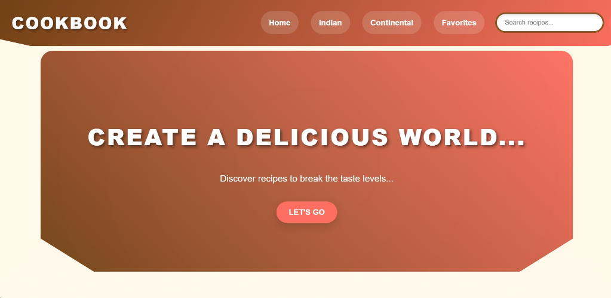

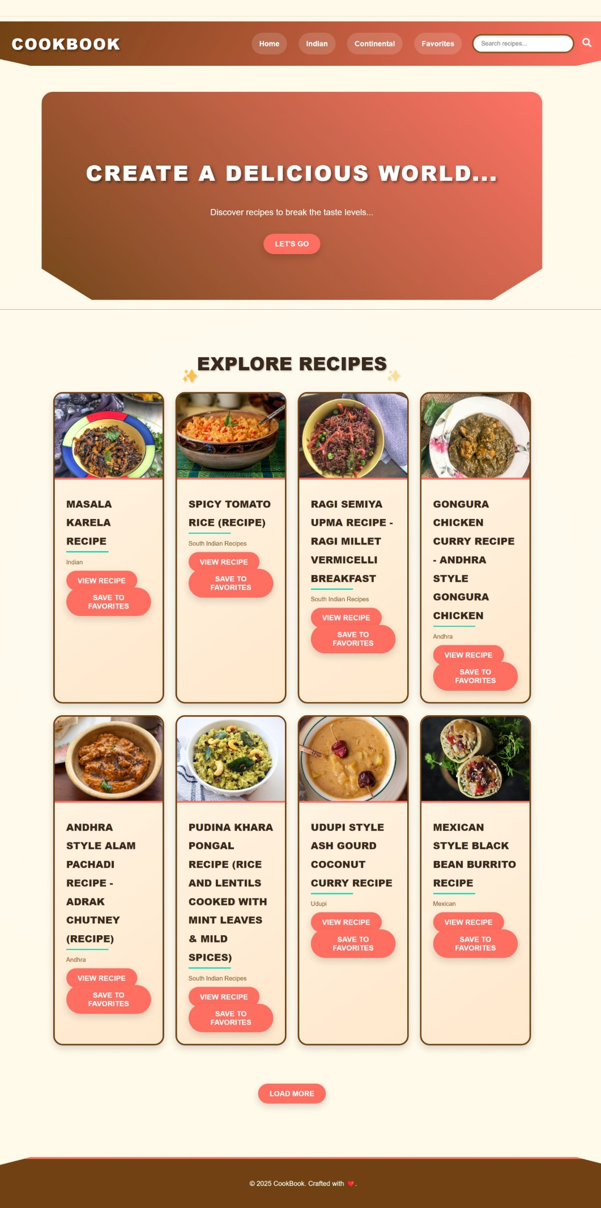

* **Search Results Page**: Shows filtered recipes with a centered title.

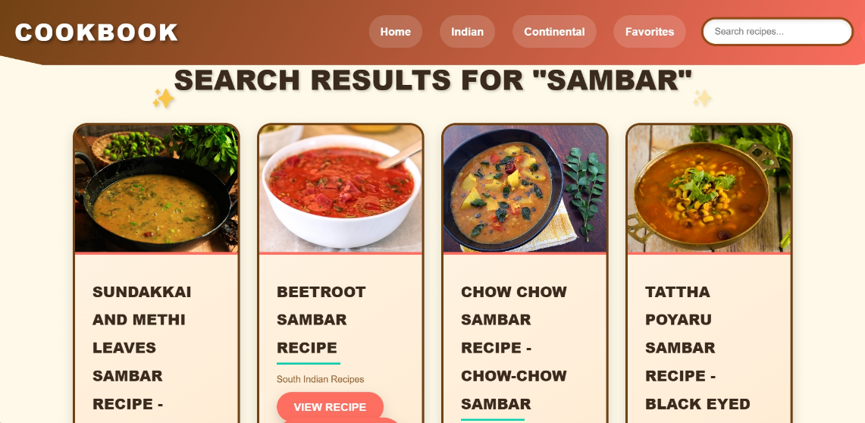

* **Recipe Detail Page:** Includes a full-width image, split layout for ingredients and instructions, and a YouTube video embed.

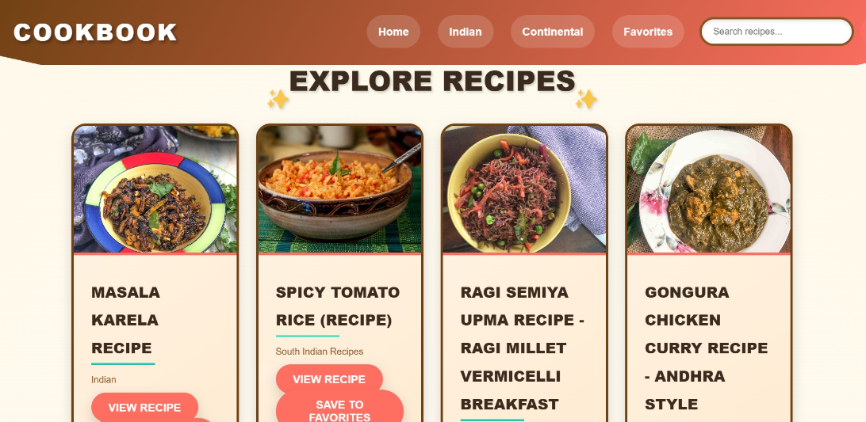

* **Favorites Page**: Displays a grid of saved recipes with "Remove" buttons.

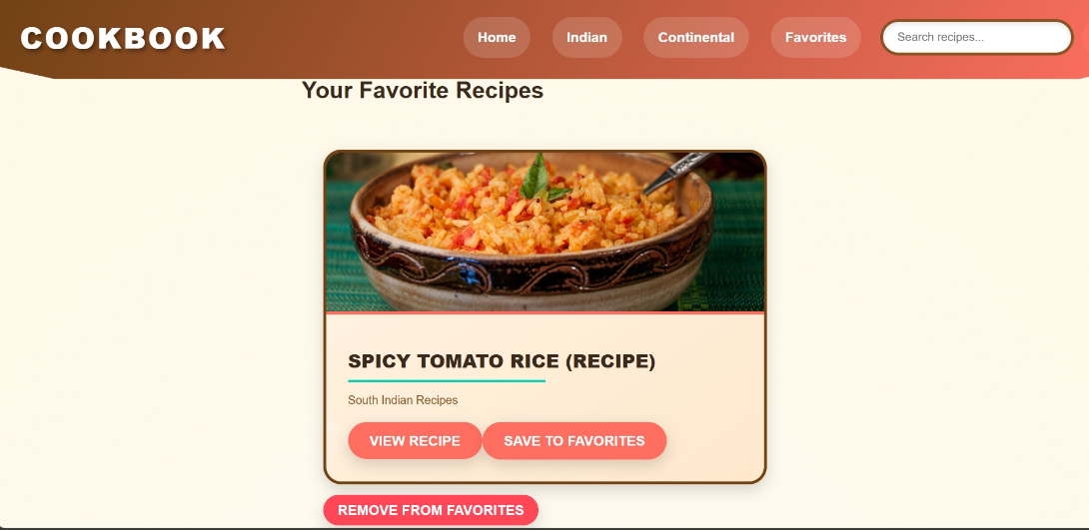

**PROJECT FLOW**

**Setup**

* Create React app: npx create-react-app cookbook-dashboard.
* Install dependencies: npm install (including react-router-dom, axios, react-icons, web-vitals).
* Configure routing and hooks.

**Design UI**

* Build Navbar, Hero, RecipeList, Category, SearchResults, RecipeDetails, Favorites, and Footer in App.js.
* Style with App.css for the "Village Cooking Theme" and index.css for global styles.

**Implement Logic**

* Fetch recipe data via useRecipes hook and axios from multiple APIs.
* Integrate YouTube API in RecipeDetails.
* Enable navigation, search, lazy loading, and favorites functionality.

**References**

* **Create React App Documentation:** <https://facebook.github.io/create-react-app/docs/getting-started>
* **React Documentation**: <https://reactjs.org/>
* **React Router Documentation:** <https://reactrouter.com/>
* **Axios Documentation:** <https://axios-http.com/docs/intro>
* **YouTube API Documentation:** <https://developers.google.com/youtube/v3>
* **React Icons Documentation**: <https://react-icons.github.io/react-icons/>
* **Web Vitals Documentation:** <https://github.com/GoogleChrome/web-vitals>
* **Jest-DOM Documentation**: <https://github.com/testing-library/jest-dom>
* **Bootstrap Documentation:** <https://react-bootstrap-v4.netlify.app/getting-started/introduction/>
* **Tailwind CSS Documentation:** <https://tailwindcss.com/docs/installation>

**CONCLUSION**

CookBook is a robust and interactive solution for culinary enthusiasts, leveraging React.js, react-router-dom, axios, and a custom useRecipes hook to deliver a feature-rich recipe exploration experience. Through its integration of multiple APIs (custom backend, TheMealDB, and YouTube), lazy loading, detailed views, trending dishes, and favorites styled with the "Village Cooking Theme," the application provides a scalable foundation for features like user customization, advanced filtering, or community engagement. The project’s responsive design, performance monitoring with web-vitals, and testing setup with @testing-library/jest-dom ensure accessibility and maintainability. With the provided GitHub repository, demo, and video links, users can explore and extend this project to suit their culinary needs. Embark on this gastronomic journey with CookBook, where every recipe becomes an adventure waiting to be discovered and savored.